Lagged cross-correlation: GBPUSD and NZDUSD
Method 12 / daily log returns / K_max=10 / Alpari D1 full available history

Study setup
Logical pair: GBPUSD , NZDUSD
Broker symbols: GBPUSD_i , NZDUSD_i
Snapshot: 2026-11-03_majors_alpari_D1
Timeframe: D1
Matched return window: 1999-01-05 to 2026-11-02 (UTC bar dates)
Matched return count n: 7203
Dropped unfinished last bar dated 2026-11-03 UTC after a tick-volume check against the prior complete day.
Lag definition: rho_X->Y(k) = Corr(x_t, y_{t+k}) on matched D1 bars
K_max = 10; headline lag k = 1 (both directions)
Complete matched rows (Excel): GBPUSD-NZDUSD_Lagged_D1.xlsx
Complete matched rows (HTML table): GBPUSD-NZDUSD_Lagged_D1_data.html

Method carried forward
Lagged cross-correlation measures Pearson correlation between matched daily log returns of close, ln(close_t / close_t-1), after shifting one series forward by k bars on the matched panel. Quotes are not inverted. rho_{X->Y}(k) = Corr(x_t, y_{t+k}) with n_k = n - k. K_max = 10 is fixed before estimation. The headline is the pre-specified lag k = 1 in both directions. k = 0 is the same-bar side check. The lag inside 1..10 with the largest absolute rho is stored as a descriptive column only; it is not a selected result. This is a linear screen, not proof of forecast edge, economic cause, or a trading signal.

Results (headline k=1)
rho_GBPUSD->NZDUSD(1): -0.005367 (n=7202)
95% Fisher interval GBPUSD->NZDUSD: [-0.028459, 0.017731]
rho_NZDUSD->GBPUSD(1): 0.000798 (n=7202)
95% Fisher interval NZDUSD->GBPUSD: [-0.022299, 0.023893]
Same-bar rho(k=0): 0.530079
Largest |rho| among k=1..10 (descriptive only, not selected): GBPUSD->NZDUSD k=5 rho=-0.025547; NZDUSD->GBPUSD k=8 rho=0.029569

CCF table
k | rho_GBPUSD_to_NZDUSD | n_GBPUSD_to_NZDUSD | rho_NZDUSD_to_GBPUSD | n_NZDUSD_to_GBPUSD
0 | 0.53007896 | 7203 | 0.53007896 | 7203
1 | -0.00536698 | 7202 | 0.00079778 | 7202
2 | 0.02495364 | 7201 | 0.0061666 | 7201
3 | -0.00646337 | 7200 | -0.00993697 | 7200
4 | 0.00876671 | 7199 | -0.0086686 | 7199
5 | -0.02554738 | 7198 | -0.00461702 | 7198
6 | -0.02176167 | 7197 | -0.01148398 | 7197
7 | 0.00594832 | 7196 | -0.00096318 | 7196
8 | -0.00142069 | 7195 | 0.02956942 | 7195
9 | -0.01419306 | 7194 | -0.01368331 | 7194
10 | -0.0233175 | 7193 | 0.00846215 | 7193

Conclusion
At the pre-specified lag k=1 for GBPUSD and NZDUSD, rho_{GBPUSD->NZDUSD}(1) = -0.0054 (n=7202) and rho_{NZDUSD->GBPUSD}(1) = 0.0008 (n=7202). Same-bar rho(k=0) = 0.5301. Largest |rho| among k=1..10 is descriptive only: GBPUSD->NZDUSD at k=5 (-0.0255); NZDUSD->GBPUSD at k=8 (0.0296). This is a linear screen, not forecast proof or a trading signal.

Charts
Daily closes

Daily log returns

CCF both directions k=0..10
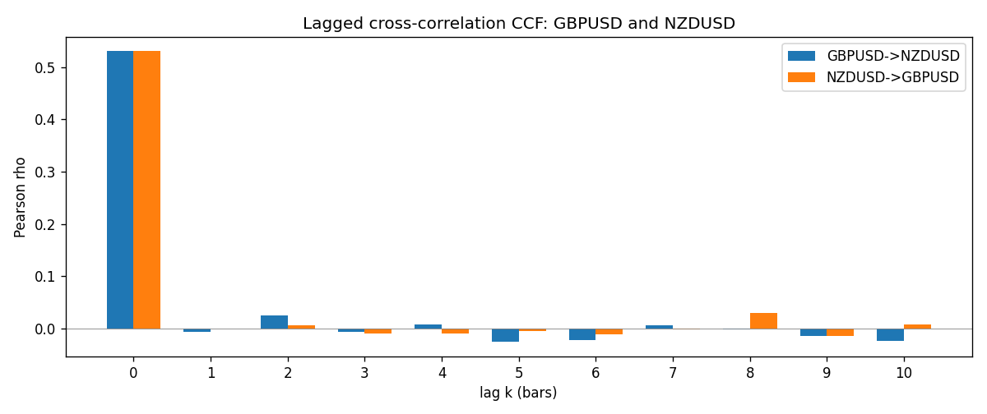

Data report
Every matched row is stored in the sibling Excel workbook named GBPUSD-NZDUSD_Lagged_D1.xlsx (sheet matched_rows). The CCF sheet holds rho(k) for k=0..10. Embedding all rows as a Word table is impractical; the Word file holds column summaries and the first and last 15 rows.
Columns: time, GBPUSD_open, NZDUSD_open, GBPUSD_high, NZDUSD_high, GBPUSD_low, NZDUSD_low, GBPUSD_close, NZDUSD_close, GBPUSD_tick_volume, NZDUSD_tick_volume, GBPUSD_spread, NZDUSD_spread, GBPUSD_real_volume, NZDUSD_real_volume, GBPUSD_log_return, NZDUSD_log_return
Column summaries (matched calculation rows)
column | count | mean | std | min | 25% | 50% | 75% | max
GBPUSD_open | 7203 | 1.5160351 | 0.21820856 | 1.06854 | 1.32502 | 1.51126 | 1.63163 | 2.1066
NZDUSD_open | 7203 | 0.65617721 | 0.10827592 | 0.3913 | 0.59107 | 0.6683 | 0.72469 | 0.88218
GBPUSD_high | 7203 | 1.5223294 | 0.21877071 | 1.08366 | 1.3298 | 1.51797 | 1.63833 | 2.1161
NZDUSD_high | 7203 | 0.66009189 | 0.10877133 | 0.3961 | 0.594565 | 0.67188 | 0.729235 | 0.88421
GBPUSD_low | 7203 | 1.5097156 | 0.21743942 | 1.03518 | 1.319525 | 1.50315 | 1.62431 | 2.0983
NZDUSD_low | 7203 | 0.65248767 | 0.1078698 | 0.3897 | 0.587935 | 0.66402 | 0.72082 | 0.87988
GBPUSD_close | 7203 | 1.5161019 | 0.21816437 | 1.06879 | 1.32515 | 1.51122 | 1.63196 | 2.1065
NZDUSD_close | 7203 | 0.65624807 | 0.10827144 | 0.3907 | 0.591395 | 0.6683 | 0.724915 | 0.8822
GBPUSD_tick_volume | 7203 | 94800.961 | 153533.35 | 62 | 9991 | 52873 | 91772.5 | 1273370
NZDUSD_tick_volume | 7203 | 68552.383 | 123030.52 | 16 | 5500.5 | 33815 | 58467.5 | 1127682
GBPUSD_spread | 7203 | 26.976121 | 19.194852 | 0 | 11 | 20 | 50 | 50
NZDUSD_spread | 7203 | 30.373178 | 25.676979 | 0 | 9 | 17 | 50 | 80
GBPUSD_real_volume | 7203 | 3.5551025e+09 | 8.4426509e+10 | 0 | 0 | 0 | 0 | 2.4038164e+12
NZDUSD_real_volume | 7203 | 1.6657093e+10 | 8.4881524e+10 | 0 | 0 | 0 | 0 | 2.705649e+12
GBPUSD_log_return | 7203 | -2.372e-05 | 0.00564203 | -0.08388241 | -0.00312422 | 3.221e-05 | 0.0031735 | 0.03112653
NZDUSD_log_return | 7203 | 5.29e-06 | 0.00764545 | -0.07027433 | -0.00426254 | 0.00021291 | 0.00457891 | 0.05966839
First 15 matched rows (selected columns)
time | GBPUSD_close | NZDUSD_close | GBPUSD_log_return | NZDUSD_log_return
1999-01-05 | 1.6547 | 0.5372 | -0.0028966287 | -0.0018597736
1999-01-06 | 1.6537 | 0.5383 | -0.00060452184 | 0.0020455609
1999-01-07 | 1.6502 | 0.5417 | -0.002118709 | 0.0062963171
1999-01-08 | 1.6405 | 0.5414 | -0.0058954193 | -0.00055396548
1999-01-11 | 1.6312 | 0.547 | -0.0056851331 | 0.010290425
1999-01-12 | 1.6349 | 0.5441 | 0.0022657001 | -0.0053157489
1999-01-13 | 1.6499 | 0.5387 | 0.0091330396 | -0.0099742238
1999-01-14 | 1.6531 | 0.5386 | 0.0019376331 | -0.00018564931
1999-01-15 | 1.6502 | 0.5382 | -0.0017558204 | -0.00074294208
1999-01-18 | 1.6522 | 0.5372 | 0.0012112405 | -0.0018597736
1999-01-19 | 1.6553 | 0.5382 | 0.0018745281 | 0.0018597736
1999-01-20 | 1.6472 | 0.5404 | -0.0049053846 | 0.0040793678
1999-01-21 | 1.6524 | 0.5426 | 0.0031518998 | 0.0040627941
1999-01-22 | 1.6565 | 0.5361 | 0.0024781662 | -0.012051689
1999-01-25 | 1.6585 | 0.5342 | 0.0012066366 | -0.0035504102
Last 15 matched rows (selected columns)
time | GBPUSD_close | NZDUSD_close | GBPUSD_log_return | NZDUSD_log_return
2026-10-13 | 1.32534 | 0.56127 | 0.0036434319 | 0.0047326165
2026-10-14 | 1.31884 | 0.55918 | -0.0049164679 | -0.0037306483
2026-10-15 | 1.32757 | 0.56185 | 0.0065976411 | 0.0047634855
2026-10-16 | 1.33257 | 0.56509 | 0.0037592051 | 0.0057501001
2026-10-19 | 1.33024 | 0.56616 | -0.0017500314 | 0.0018917133
2026-10-20 | 1.3377 | 0.56827 | 0.0055923442 | 0.0037199341
2026-10-21 | 1.33937 | 0.57003 | 0.0012476328 | 0.0030923331
2026-10-22 | 1.33967 | 0.56815 | 0.00022396082 | -0.0033035227
2026-10-23 | 1.33684 | 0.56991 | -0.0021146949 | 0.0030929853
2026-10-26 | 1.33359 | 0.56826 | -0.0024340661 | -0.0028993932
2026-10-27 | 1.33044 | 0.56811 | -0.0023648393 | -0.00026399852
2026-10-28 | 1.33254 | 0.56261 | 0.0015771808 | -0.0097283914
2026-10-29 | 1.33733 | 0.56296 | 0.0035881935 | 0.00062190714
2026-10-30 | 1.33913 | 0.56307 | 0.0013450605 | 0.00019537668
2026-11-02 | 1.3406 | 0.56161 | 0.0010971256 | -0.0025962955

